Driveway / Access Permit Application

Shafer Township,
18259 St. Croix Trail
Shafer, MN 55074

Phone: (651)583-2168

Name of proposer_____________________________________________________Date_________________
Address of proposer________________________________________________________________________
Phone numbers: (____)__________________ (____)_________________ Co. PID# ___________________
Purpose of Access__(home)__(outbuildings)__(field)___(other)_____________________________________
Number of Existing Accesses to the property____________________________________________________
Legal Description of property served__________________________________________________________

Sketch of the Property showing any present and proposed access: 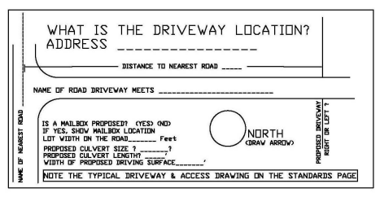
REPAIR ESCROW

Driveway fronts on an existing gravel road_ ESCROW DEPOSIT = $1500
Driveway fronts on blacktop road ESCROW DEPOSIT = $6000
Escrow amount $__________________ (See Driveway / Access Permit Procedure)
Dated ___/____/_____ as a _____________________________________________________________
AS A (cash deposit) OR (bond) OR (Letter of credit) X OUT THE NOT APPLICABLE
Record of inspection by ______________________________________________ Dated ___/____/____
Result of inspection ___________________________________________________________________ Record of escrow released by ____________________________________ Dated ___/____/____
The undersigned hereby makes application for permission to construct the above described driveway access. Said driveway access shall comply with all Township, County and State requirements. It is agreed that all work shall be completed within 180 days and must be done to the satisfaction of Shafer Township. It is further agreed that no work shall commence until this application is approved in writing below and the permit actually issued. It is expressly understood that this permit is conditioned upon replacement and restoration of the Township roads and boulevards to their original or satisfactory condition as determined solely by the Township. This permit is non-transferable.

Permit Approved by: ___________________________________________________ Dated ___/____/____
Shafer Township
Driveway / Access Permit Procedure
1. An escrow is required for all permits.
If a driveway fronts on an existing gravel road, the deposit is $1500
If the driveway fronts on a bituminous paved road the escrow deposit is $ 6000
$100 non-refundable administration fee will be charged against said deposit.

2. If the property has an existing driveway, or a field driveway, the driveway must meet the specifications as listed in this application. If the driveway does not meet the specifications, it must be brought up to specifications prior to a building permit being issued.
3. A minimum of two (2) inspections are required; one for proposed access location so that a building permit may be issued by the County and a final inspection to check compliance in building the access (final inspection should be near the date of occupancy). Inspections are $25 per inspection. Extra inspections required due to failure to comply with all Township requirements will result in an additional $25 per inspection.
4. Applicants shall place a lath or stake, with flagging attached, at the center of the proposed access . Complete directions to property shall be included with driveway permit. Contact Shafer Township for the initial inspection.
5. Shafer Township will inspect the site for drainage requirements and location approval. Shafer Township will notify the applicant of any special requirements. Size will be determined by the Driveway inspector.
6. After initial inspection, if the location and plan are acceptable, the Township will approve the County’s issue of your building permit.
7. In order for all remaining monies to be refunded to the applicant upon satisfactory completion of the access, the applicant MUST request a final inspection date within 300 days of the permit issue date. Failure to call and secure a final inspection date within 300 days of permit issue date will cause automatic forfeiture of the entire balance of the escrow.
8. Shafer Township reserves the right to apply all monies deposited for the permit to properly construct or complete the driveway / access.
9. If the applicant requires a culvert, the applicant must furnish the culvert. Culverts are not provided by Shafer Township. All culverts must be steel or concrete (culverts, having a total length of 46 feet with flared ends. Culverts of other materials (HDPE, etc) will only be permitted with the formal approval of the township. Conditions of that approval include:
a) Slope of the pipe flow line, ability to prevent low spots.
b) Soil at the site, compaction of the subgrade, and bedding proposed
c) Depth of the pipe between the crown of the pipe and the driveway surface.
10. It is the responsibility of the applicant and his contractor to locate all utilities, etc. to have them staked, and to preserve them as necessary.
11. Every residential driveway shall include a standardized house address and post which shall be obtained from the township. Cost of these materials will be deducted from the deposits listed in 1. above.
12. Mailboxes of the swinging type are required. Mailbox and swing systems may be purchased from the Township. Mailboxes are to be installed in accordance with the attached drawing. To arrange pick-up, call Shafer Township at the town hall (651) 583-2168.
13. Questions? Call Shafer Township Clerk at (651) 583-2168.

Specifications for a driveway / access

1. If a culvert is required, its size shall be as determined by the Township.
Minimum size = 15” Inside Diameter. Aprons for 4:1 slopes are required.

2. Driveway/Access width must be 16 feet driving surface width at the Township right of way line and edges of driving
surface shall have a 20’ radius. See appended drawing.

3. Driveway side-slopes shall be a minimum of 4 horizontal to 1 vertical. Up to a 6:1 in-slope may be allowed, but this will require a longer culvert. The attached driveway dimension sheet is part of these requirements.

4. Driveway side slopes must be seeded and blanketed upon completion.

5. Driveway must slope downward from the Township road, bringing runoff to the ditch centerline. Driveways will not be allowed on the end of roads or on turn-arounds without prior approval of the Township Board.

6. Driveway must be surfaced with Class 5 Aggregate, bituminous, crushed rock or other approved materials to a minimum depth as follows:
Bituminous........................................................... One and one half inches over 8” base
Class five............................................................. Four inches
Crushed rock:....................................................... Four Inches
The township is not responsible for bituminous placed on the right of way.
7. Contact the Township for location inspection. If all requirements are agreed to by the owner, the contractor and the Township inspector, the Township will issue a Notice to Chisago County Zoning giving approval for a building permit in Shafer Township.
8. The access must be installed and usable prior to construction of buildings. If not, the site will be deemed in violation and the Township will request that the County stop all construction. Class 5 is not required until final inspection is made, or as is otherwise directed by the Township inspector. In cases where mud being dragged onto the existing road is an issue, the proposer shall provide a rocked “drag-out” area 40’ long x 16’ wide.
9. Twenty-four (24) hour prior notice must be given for inspection. If you have questions or want inspections, please contact the Township Clerk at (651) 583-2168.

MAILBOXES
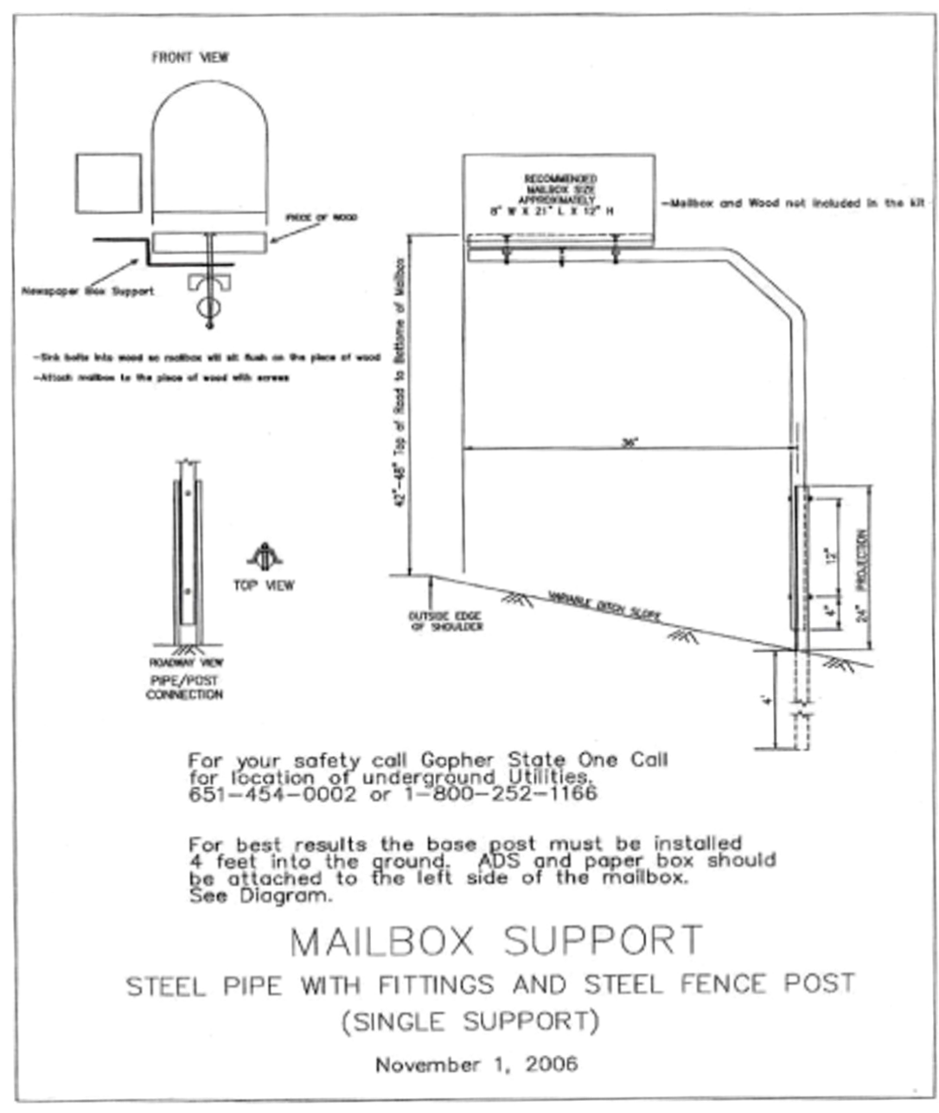

Mailboxes of the swinging type are required by Shafer Township.
Mailbox accessories can be purchased from Shafer Township at their cost.
Mailboxes are the responsibility of the individual.
Mailbox posts must be sunk no less than 4 to 4-1/2 feet deep due to frost.
The township will advise as to which side of the road the mailbox shall be placed.
To arrange for your mailbox, call Shafer Township at (651)583-2168.

